Biosignal recognition training tool

Anzhelina Andriyanova and Angèle Umba

Supervisor: Prof. Dr. Paul Devos

Academic year: 2017 – 2018

Content table

List of figures 1

Introduction 1

Heart signals 1

Normal 1

Abnormalities 1

Long signals 1

Normal 1

Abnormalities 1

Program: C# 1

Main window 2

Tabs 1

Training 1

Learning 1

Exam 1

Add 1

Database 1

Static 1

Dynamic 1

Future work 1

Biosignals 1

Database 1

Program: C# 1

Appendix 1

List of figures

Introduction

The goal for this project is to create a training tool to gain the knowledge of heart- and lung sounds. The user will have the possibility to become familiar with several sounds of normal and abnormal hearts and lungs due to a program in C#. A database which contains the basic characteristics of the wav-files is integrated in a WPF-application. The graphical properties are stored in a xmal-file while the logic linked to the design can be found in the xmal.cs-file. The corporate identity of UGent was used as a reference to decide which colors and font-family to implement.

There are four tabs available once the application is launched: training, learning, exam and add. Each of those tabs are sessions which provides their own functionalities.

Heart signals

Normal

Abnormalities

Long signals

Normal

Abnormalities

Program: C#

As mentioned before, WPF-application to accomplish the goal of this project. WPF stands for Windows Presentation Foundation which is Microsoft’s latest approach to create graphic user interface (GUI). This allows you to dynamically use a wide range of GUI elements as textboxes, buttons, etc. These elements can be modified in a .xmal-file. A preview of how your GUI will look like gets refreshed every single time you change something in this file. To make those elements interact with each other or other xmal-files, a xmal.cs-file is linked. All the logic can be stored in there to make the application operational.

This project contains four xmal-files and equally as many xmal.cs-files. These have been implemented separately to create a distinct separation between all the tabs.

The main window serves as an entry to all the different tabs. A START-button has been linked to three of the four tabs, and a HOME-button will do the exact opposite. Tab Add doesn’t have a separate xmal-file because the corresponding logic is minimal.

All the implemented tabs will be describes thoroughly and illustrated in the next sections.

Main window

This window can be considered as the general input of this project. Not only is this the entry to the different xmal- and xmal.cs-files, but also a way to enter other wav-files in the database that is available at the launch of this application.

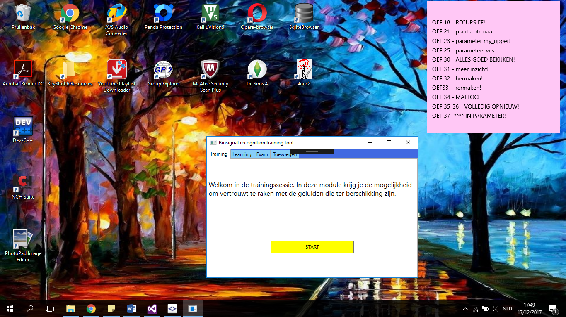

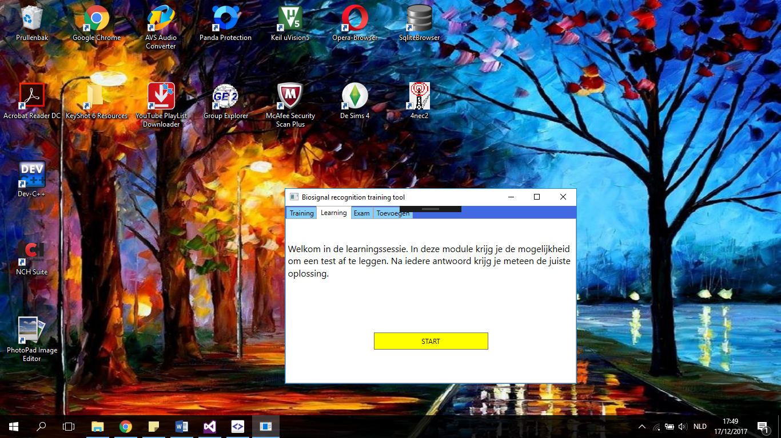

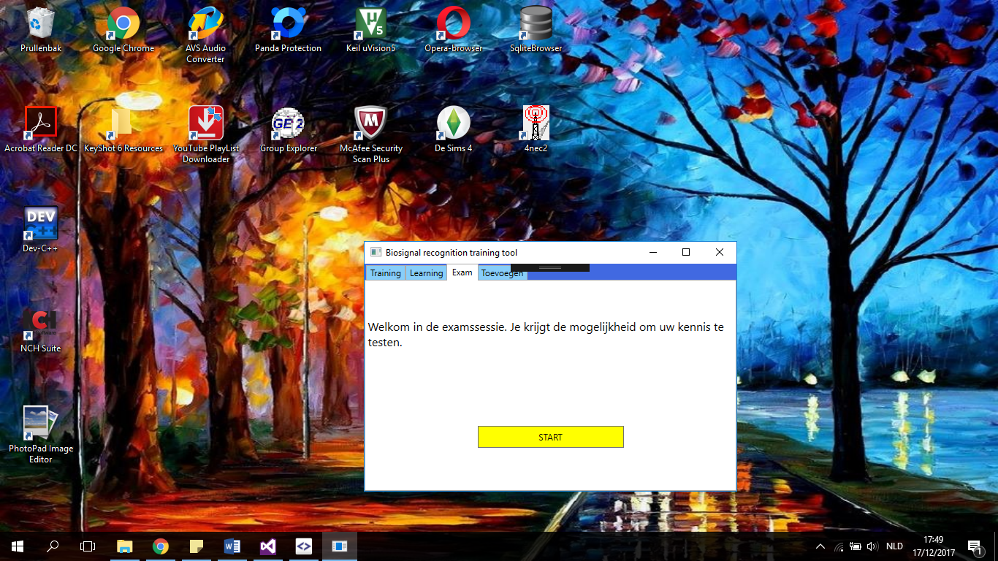

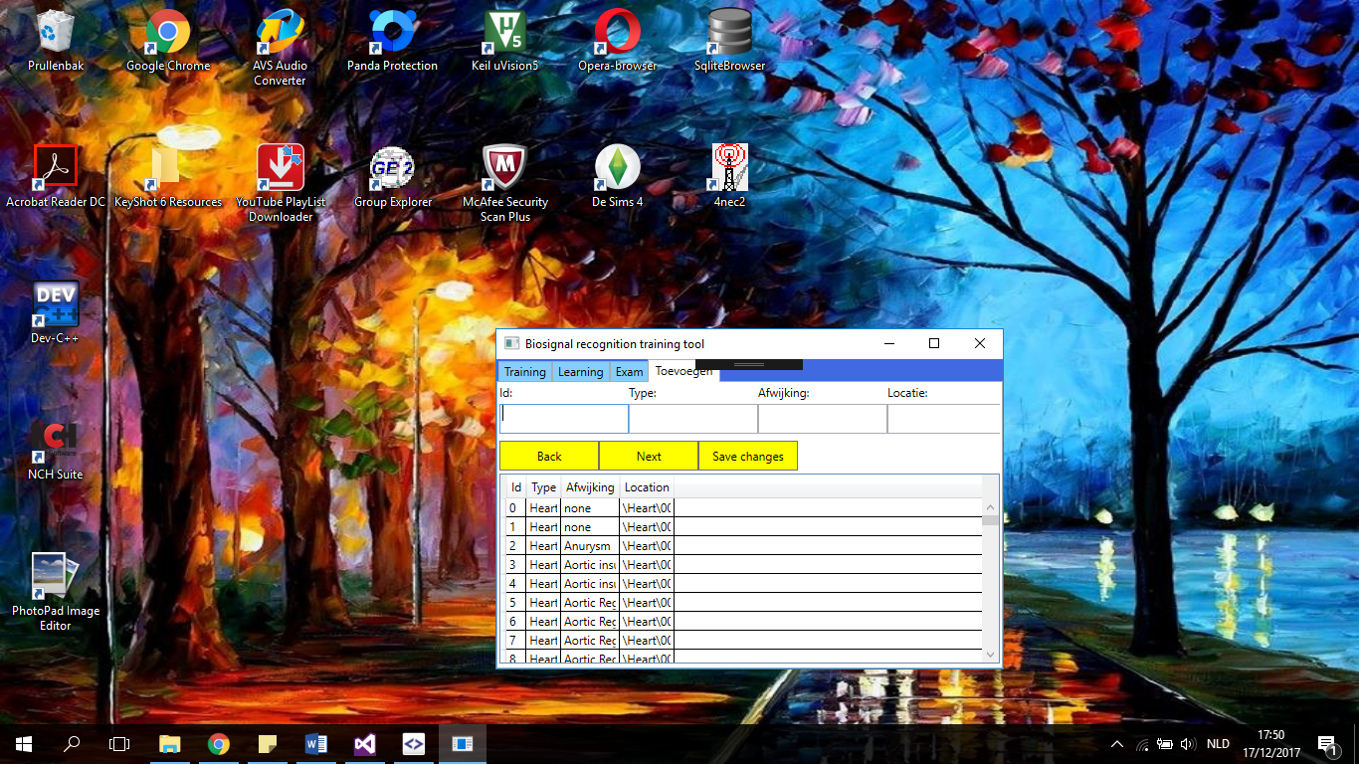

Figure 1: The different tabs on the main window

The windows of all the possible tabs are shown in figure 1 from up to bottom. Each tab except the ***add*** tab contains a button and a text block. To initiate those tabs in the main window, a snippet of the code is shown in figure 2.

|  |
| --- |
| <TabControl Background="White">  <TabItem Header="Training" Background="LightSkyBlue">  …  </TabItem>  <TabItem Header="Learning" Background="LightSkyBlue">  …  </TabItem>  <TabItem Header="Exam" Background="LightSkyBlue">  …  </TabItem>  <TabItem Header="Toevoegen" Background="LightSkyBlue">  …  </TabItem>  </TabControl> |

Figure 2: Code to implement the several tabs in the main window.

An introduction is given while residing on a specific tab to prepare you to start a session.

Tabs

This project provides different learning experiences which are integrated in the three tabs described below. The training session creates the opportunity to become familiar with the different heart and lung sounds which are fetched from the database. Secondly, the test session fabricate a concatenation of three songs, four times in a row in a random sequence as multiple choice test. Lastly, there is an exam session where one can test their skills by writing the abnormalities of the heart sounds that are playing in the background.

Training

The window shown at the top image in figure 3 is the first one seen once the training session is started. The first heart sounds in the database is set as a default value to prevent errors once the play button is pressed.

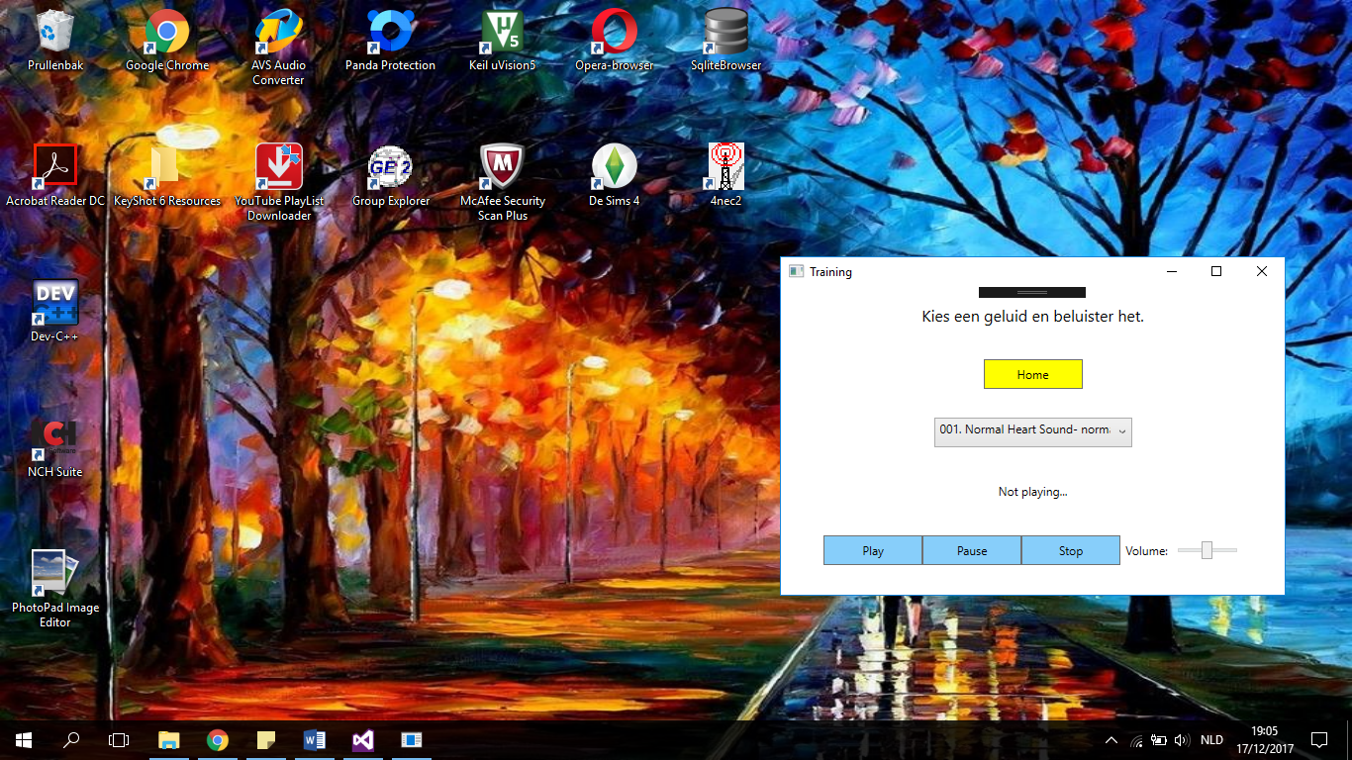

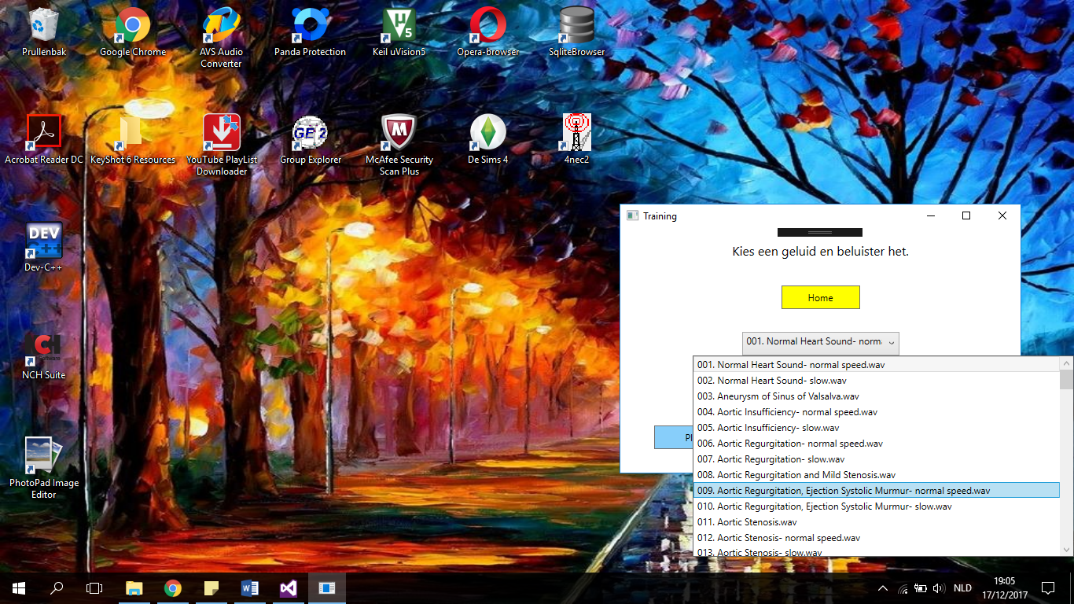

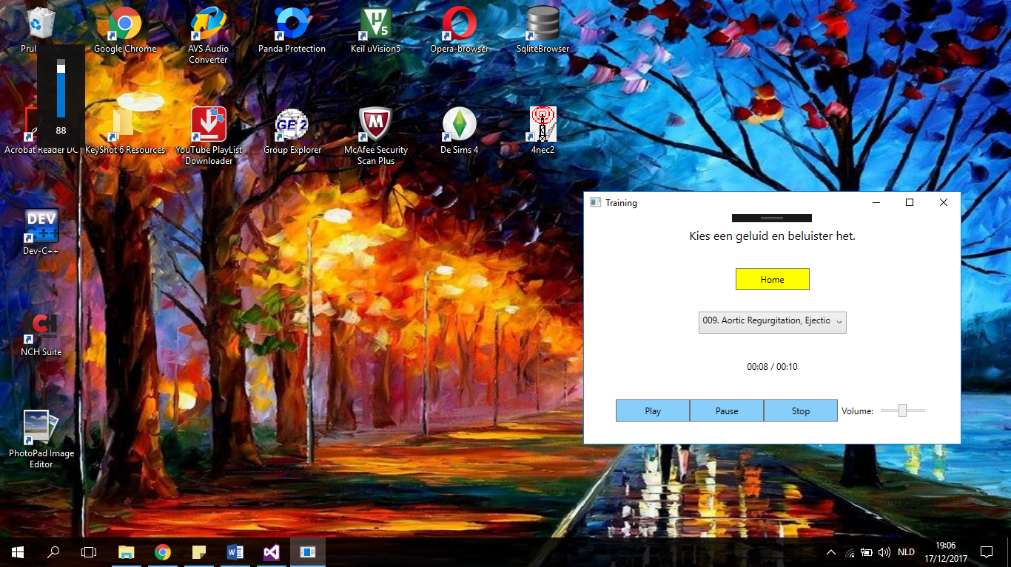

Figure 3: The different abilities of the training window

Learning

The user needs to recognize the different sounds, point it out and submit it. Right after that, the correct answer gets projected

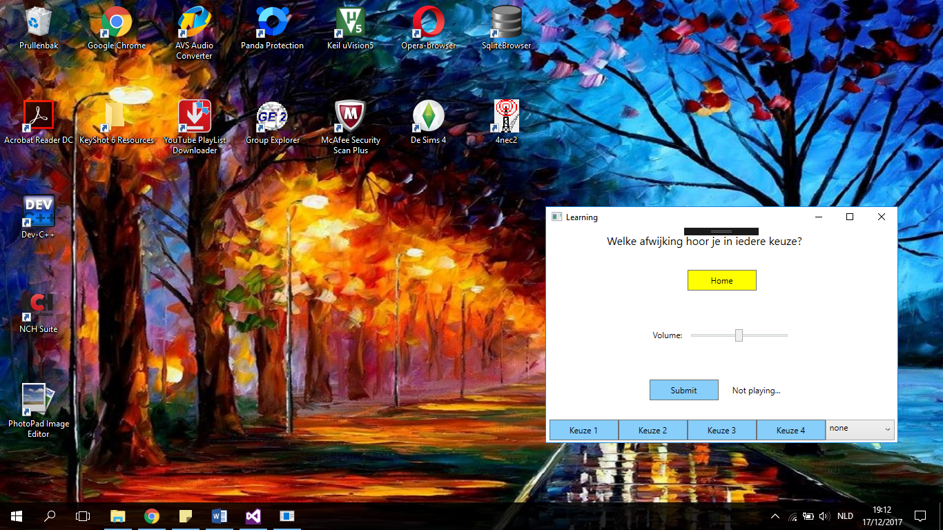

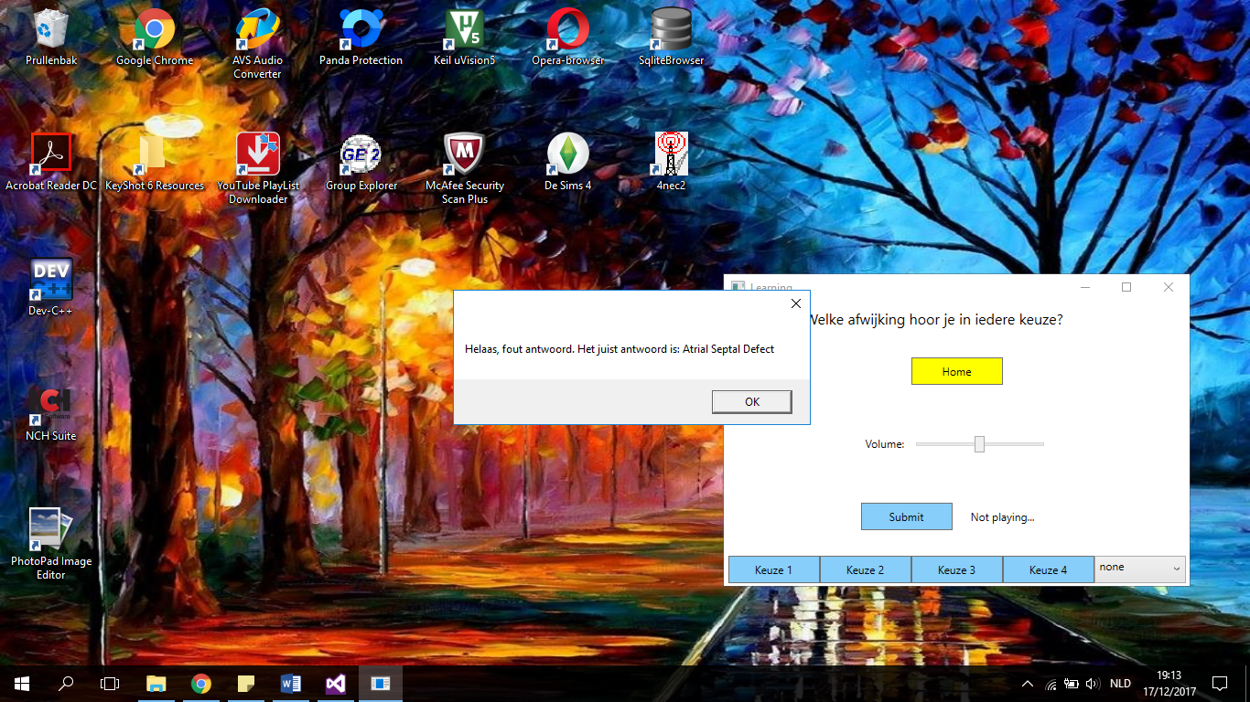

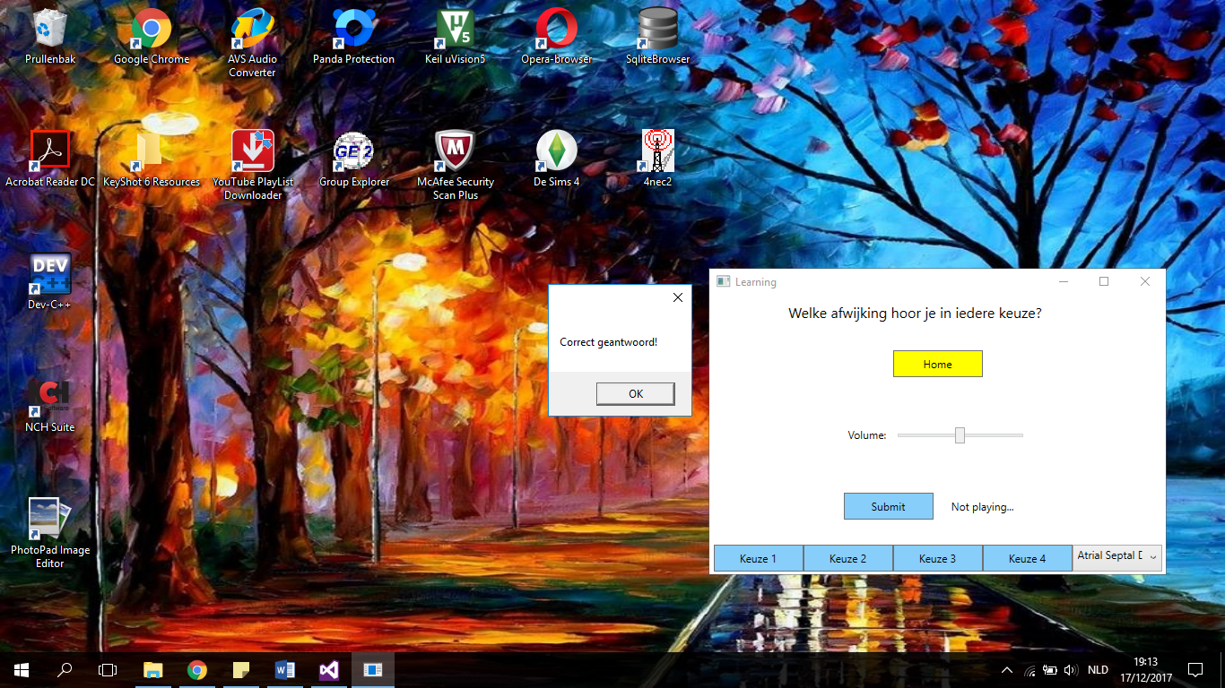

Figure : The different abilities of the learning window

Exam

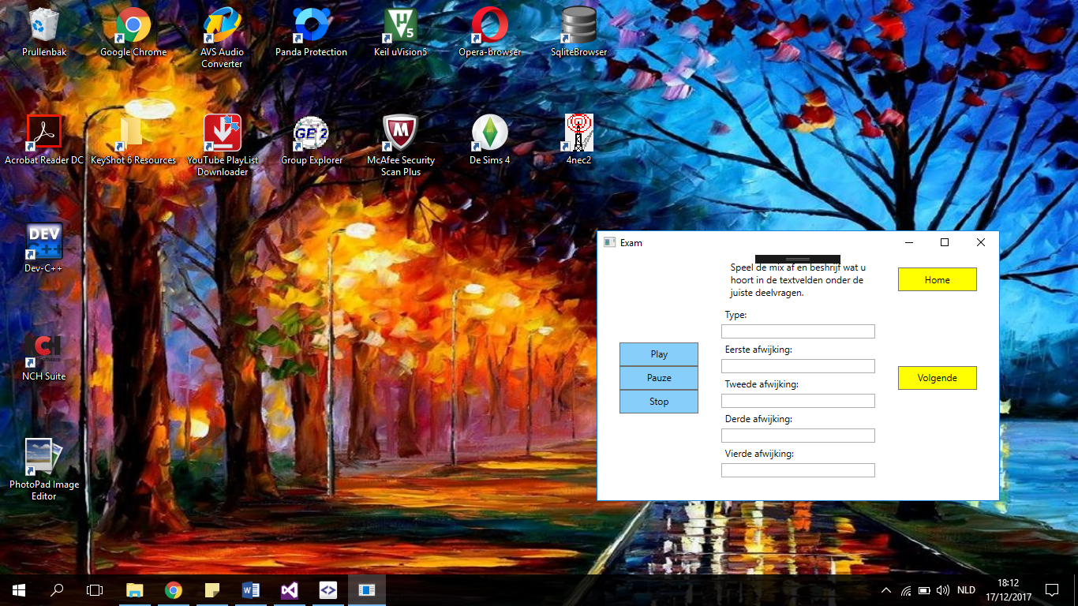

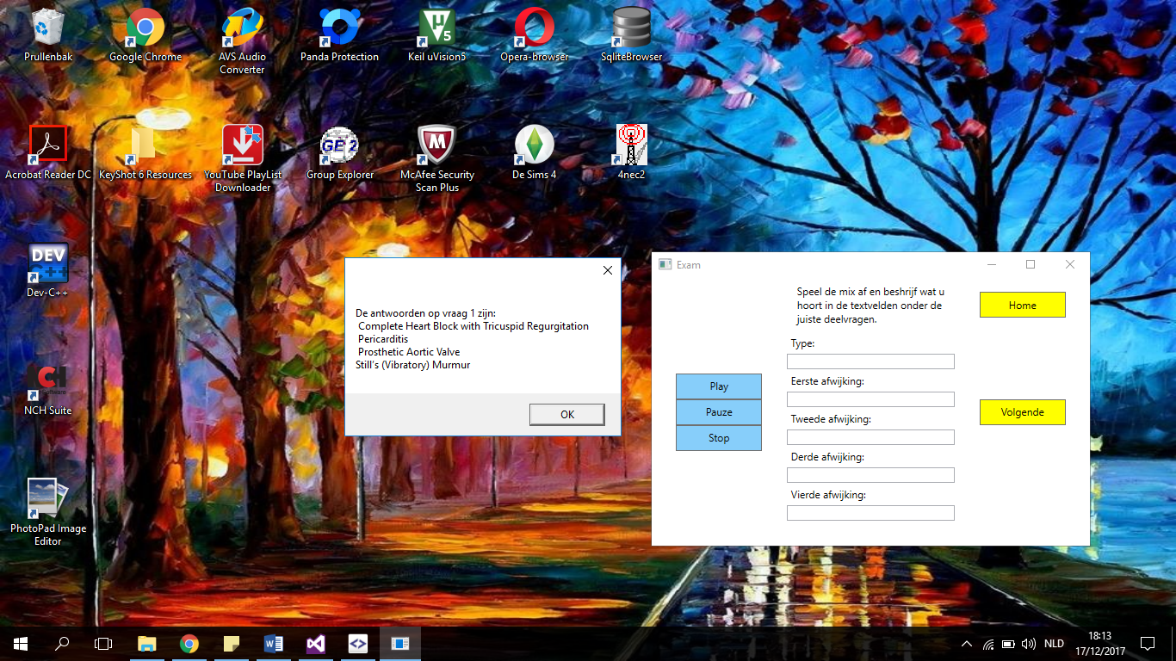

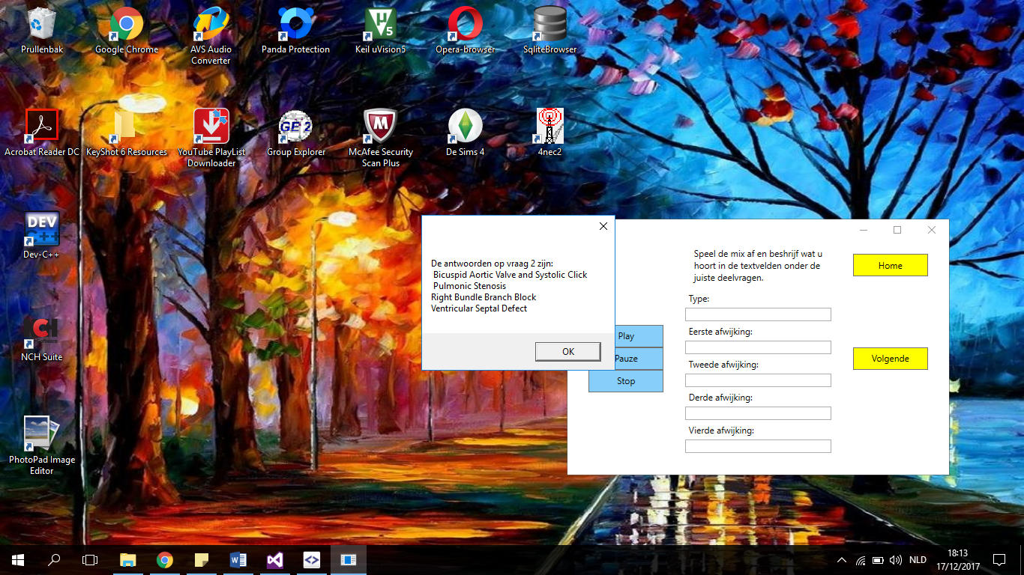

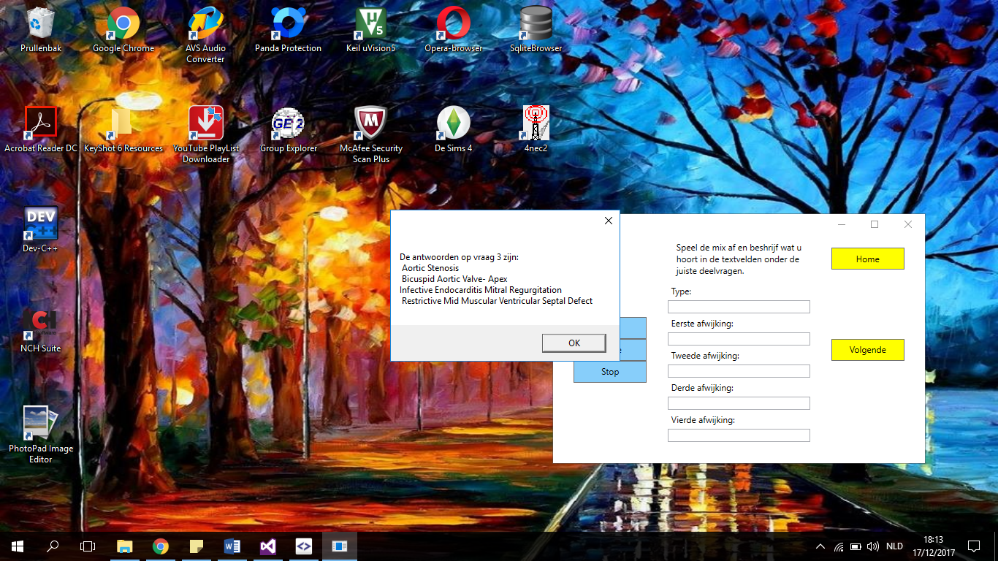

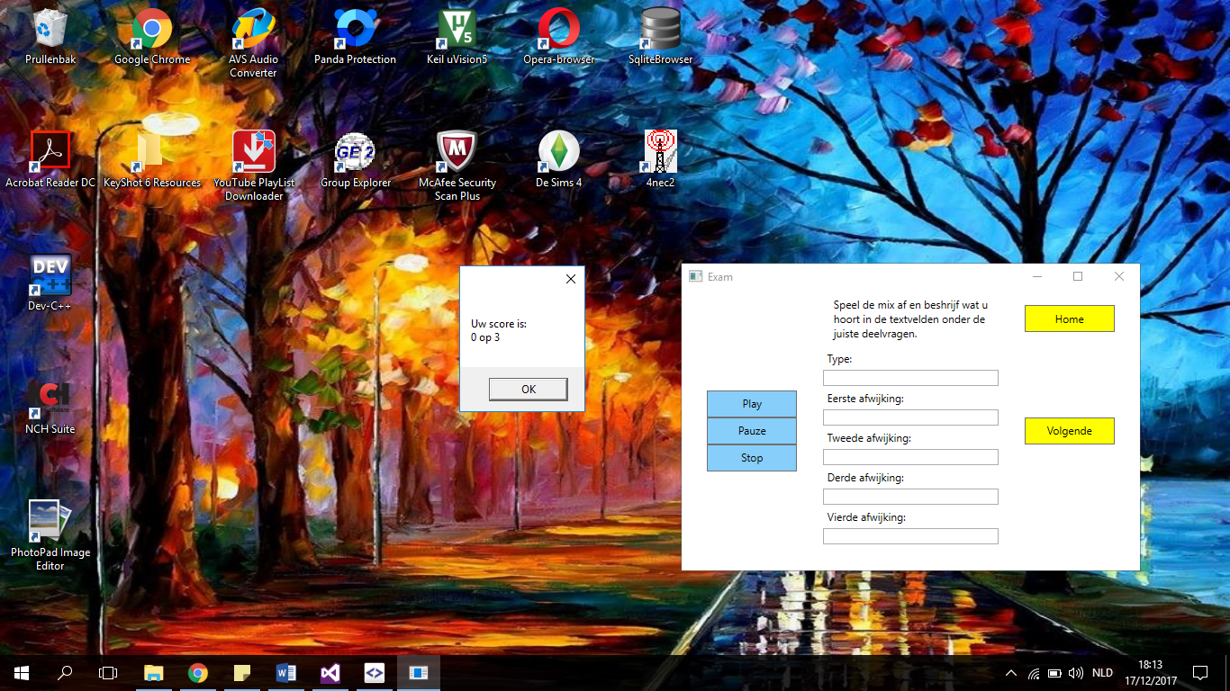

Figure : The different abilities of the exam window

Add

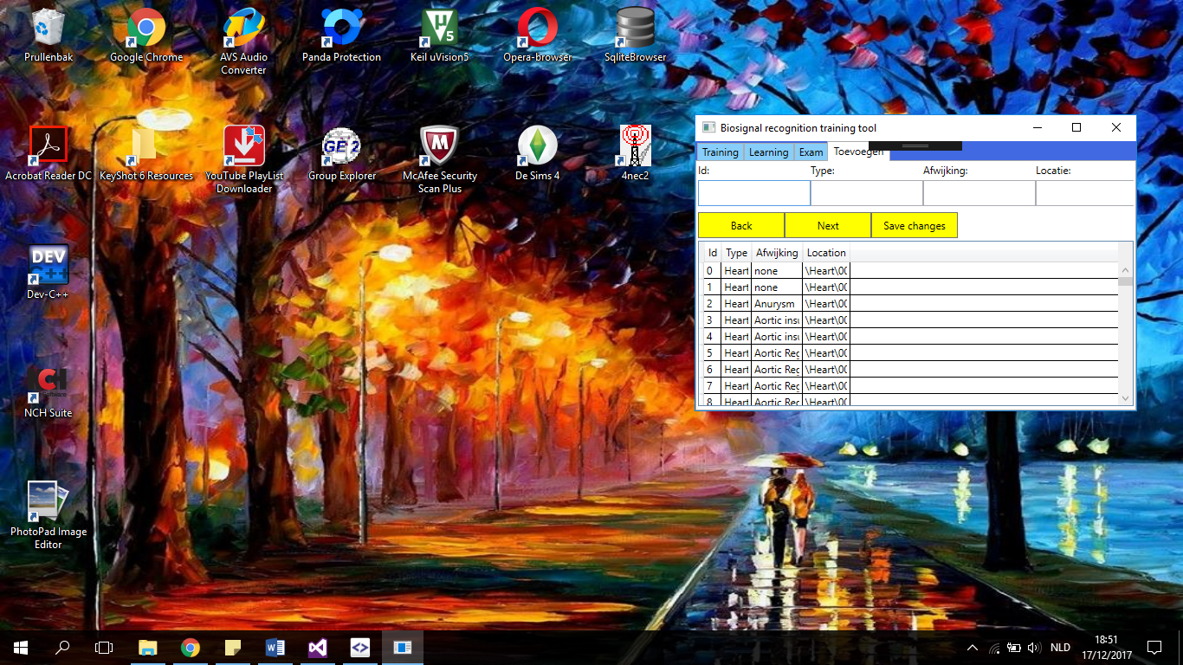

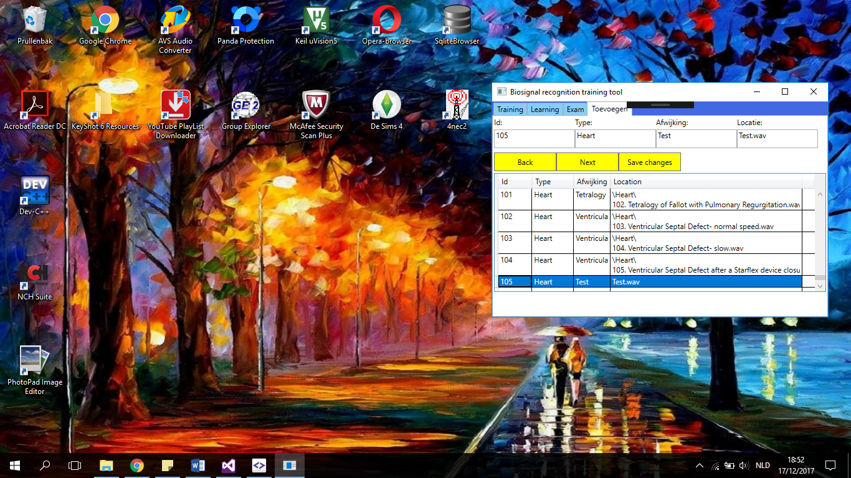

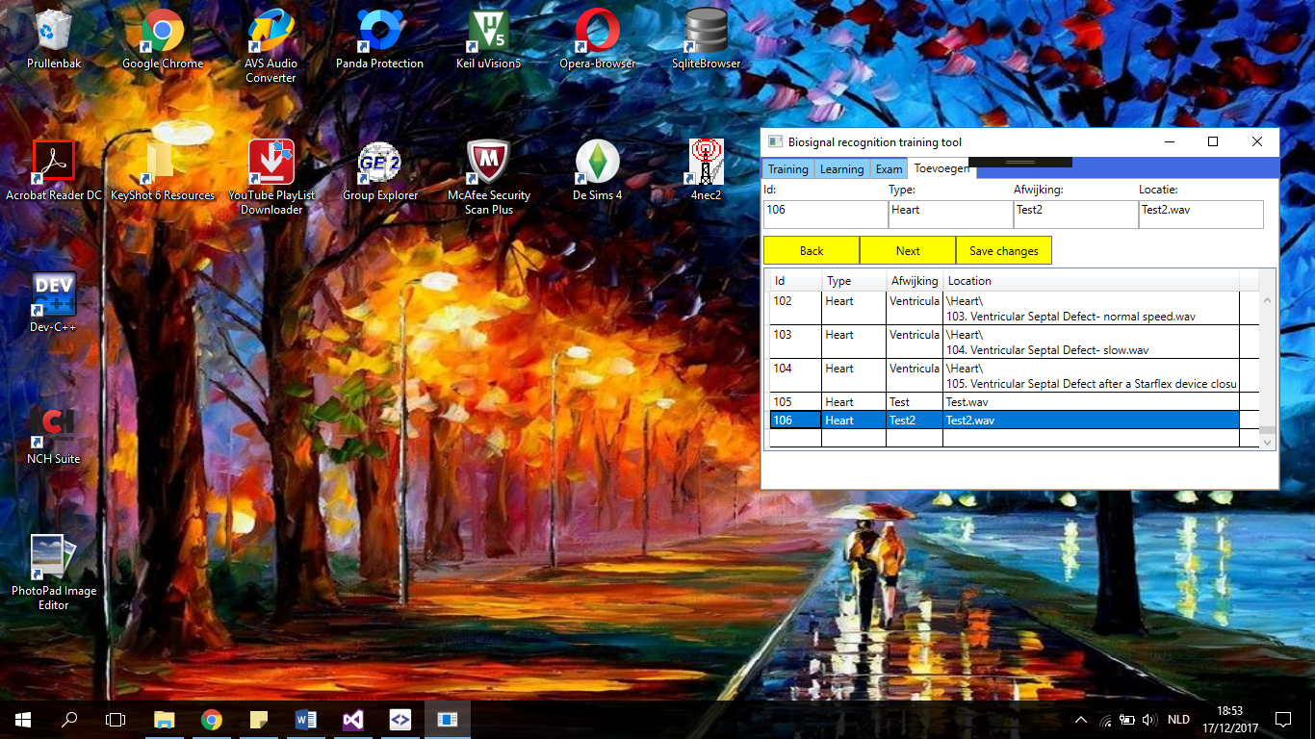

Figure : The different abilities of the add tab

Database

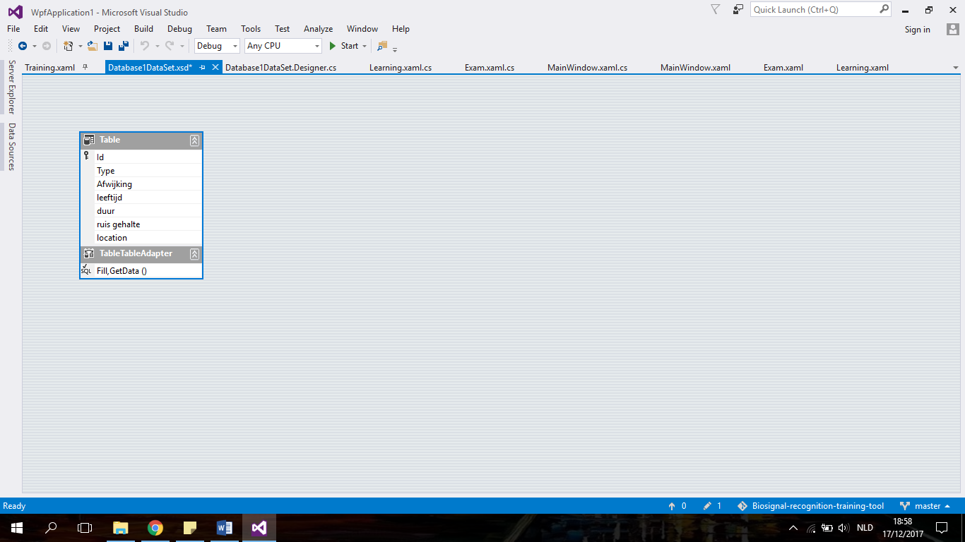

Static

Dynamic

Future work

Biosignals

Database

Program: C#

Appendix